1. SELECT * FROM `data_jenis_obat` WHERE 1 ORDER BY jenis_obat ASC;

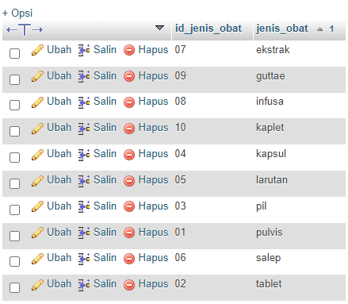

1. SELECT * FROM `data_jenis_obat` WHERE jenis_obat LIKE 'p%';

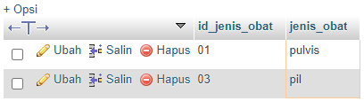

1. SELECT * FROM `data_obat` WHERE harga BETWEEN 5000 AND 10000;

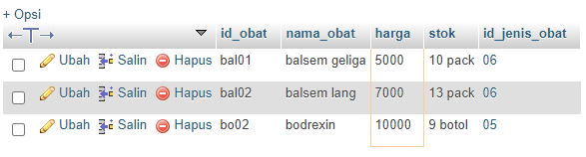

1. SELECT nama_obat, harga, stok FROM `data_obat` WHERE harga <= 15000;

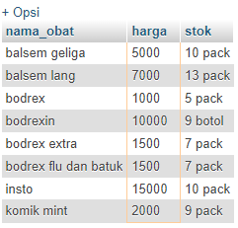

1. SELECT nama_pegawai AS nama, jenis_kelamin, tanggal_lahir AS tanggal FROM `data_pegawai` WHERE jenis_kelamin = 'laki-laki';

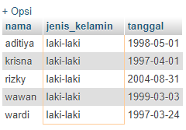

1. SELECT nama_pegawai AS nama, jenis_kelamin, telepon FROM `data_pegawai` WHERE jenis_kelamin = 'perempuan' AND alamat = 'puri citra';

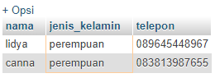

1. SELECT * FROM `data_pelanggan` WHERE alamat = 'taman pipitan indah' ORDER by id_pelanggan DESC;

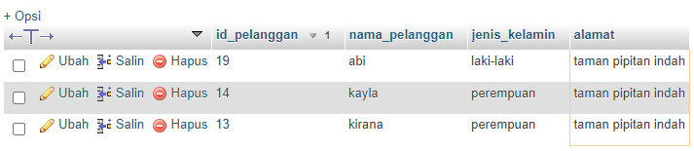

1. SELECT nama_pelanggan as nama, jenis_kelamin as jk, alamat FROM `data_pelanggan` WHERE 1 ORDER BY nama_pelanggan ASC;

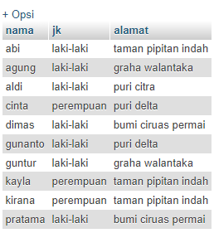

1. SELECT tanggal, id_pelanggan as pelanggan, id_pegawai as pegawai, id_obat as obat, id_jenis_obat as jenis_obat FROM `data_penjualan` GROUP by id_obat ASC;

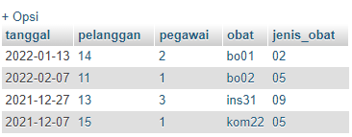

1. SELECT * FROM `data_penjualan` WHERE total >= 5000 GROUP BY id_pelanggan;

